**AI POWERED CHATBOT**

**By**

**HARSHAL VINAYAK SHINDE**



**DEPARTMENT OF MCA (ENGINEERING)**

Gokhale Education Society’s

R.H.SAPAT COLLEGE OF ENGINEERING, MANAGEMENT STUDIES AND RESEARCH, Nashik-5

[2020-2021]

**AI POWERED CHATBOT**

**In partial fulfillment of requirements for the degree of**

**Master of Computer Application In**

**Engineering**

**Submitted By:**

**HARSHAL VINAYAK SHINDE**

**Under the Guidance of**

**Prof. TRUPTI U. AHIRRAO**



**DEPARTMENT OF MCA (ENGINEERING)**

Gokhale Education Society’s

R.H.SAPAT COLLEGE OF ENGINEERING, MANAGEMENT STUDIES, AND RESEARCH, Nashik-5 [2020-2021]



Gokhale Education Society’s

R.H.SAPAT COLLEGE OF ENGINEERING, MANAGEMENT STUDIES AND RESEARCH, Nashik-5

[2020-2021]

**CERTIFICATE**

This is to certify that-

HARSHAL VINAYAK SHINDE

(Roll.No:22)

has completed his Project work and submitted the report on, **”AI POWERD CHATBOT”**

Of the Year 2020-21 towards the partial fulfillment of TY(MCA) as per SavitriBai Phule Pune

University.

**Date:**

**Place:**

Dr.P.C.Kulkarni

**Principal**

Prof. P.A.Chaudhari

**H.O.D**

Dept.of MCA(Engg)

Prof. Trupti U. Ahirrao

**Project Guide**

**ACKNOWLEDGEMENT**

Every work is the source that requires support from many people and areas. It gives us the proud privilege to complete the Project on **AI POWERED CHATBOT** under the valuable guidance and encouragement of our guide **Prof. TRUPTI U. AHIRRAO.**

I am also extremely grateful to our respected H.O.D. (MCA Eng. Dept.) **Prof.P.A.Chaudhari** and **Prof. Pranjali Deshmukh** (Project Coordinator) for providing all facilities and every help for the smooth progress of a Project.

I would also like to thank all the Staff Members of the MCA Department for timely help and inspiration for the completion of the Project.

“I would like to place on record our sincere thank to my friends for their helping during project development.

Harshal Vinayak Shinde

(Roll no.22)

T.Y.MCA

A chatbot is a web application that is used to interact between a computer and a human in a natural language like humans chat. Chatbot chats with the user in a conversation in place of a human and reply to the user.

The goal of this report on chatbot was to resemble a human being in the way they interact, trying to make the user think he is chatting with another human being. The chatbot application helps the students to access university-related information from anywhere with an internet connection.

This system reduces the work of college administration providing information to students and also reduces the workload on the staff to answer all the queries of the students.

**Contents**

1. INTRODUCTION 1

1.1 Problem definition . . . . . . . . . . . . . . . . . . . . . . . . . . . . . . . . 1

1.2 Objectives and Scope . . . . . . . . . . . . . . . . . . . . . . . . . . . . . . . 1

1.2.1 Objective . . . . . . . . . . . . . . . . . . . . . . . . . . . . . . . . . 1

1.2.2 Scope . . . . . . . . . . . . . . . . . . . . . . . . . . . . . . . . . . . 1

1.3 Organization Of Report . . . . . . . . . . . . . . . . . . . . . . . . . . . . . 1

1.3.1 Literature Survey . . . . . . . . . . . . . . . . . . . . . . . . . . . . . 1

1.3.2 Software Requirement Specification . . . . . . . . . . . . . . . . . . . 2

1.3.3 Design And Modeling . . . . . . . . . . . . . . . . . . . . . . . . . . . 2

1.3.4 Test Specification . . . . . . . . . . . . . . . . . . . . . . . . . . . . . 2

1.3.5 Result And Analysis . . . . . . . . . . . . . . . . . . . . . . . . . . . 2

1. Literature Survey 3

2.1 Existing system . . . . . . . . . . . . . . . . . . . . . . . . . . . . . . . . . . 3

2.1.1 Drawbacks of existing system . . . . . . . . . . . . . . . . . . . . . . 3

2.2 Proposed system . . . . . . . . . . . . . . . . . . . . . . . . . . . . . . . . . 3

2.2.1 Proposed system has following advantages . . . . . . . . . . . . . . . 3

1. Software Requirement Specification 5

3.1 Software Requirement . . . . . . . . . . . . . . . . . . . . . . . . . . . . . . 5

3.2 Hardware Requirement . . . . . . . . . . . . . . . . . . . . . . . . . . . . . . 5

3.3 Test Data Requirement . . . . . . . . . . . . . . . . . . . . . . . . . . . . . . 5

1. Design And Modelling 6

4.1 Architectural Design . . . . . . . . . . . . . . . . . . . . . . . . . . . . . . . 6

4.1.1 INPUT DESIGN . . . . . . . . . . . . . . . . . . . . . . . . . . . . . 6

4.1.2 OUTPUT DESIGN . . . . . . . . . . . . . . . . . . . . . . . . . . . . 6

4.1.3 INTERFACE DESIGN . . . . . . . . . . . . . . . . . . . . . . . . . . 6

1. Implementation 10

A. AIML 10

* + 1. B. Lemmatization and POS Tagging Using WordNet 10
    2. C. Semantic Sentence Similarity 11
    3. D. Log files 11

|  |  |  |  |  |
| --- | --- | --- | --- | --- |
| **6** | **Testing** | | | **12** |
|  | 6.1 System Testing . . . . . . . . . . . . . . . . . . . . . . . . . . . . . . . . . . | | | 12 |
|  | 6.1.1 Unit Testing . . . . . . . . . . . . . . . . . . . . . . . . . . . . . . . | | | 12 |
|  | 6.1.2 Integration Testing . . . . . . . . . . . . . . . . . . . . . . . . . | | | 12 |
|  | 6.1.3 Validation Testing . . . . . . . . . . . . . . . . . . . . . . . . . . . . | | | 12 |
|  | 6.1.4 Verification Testing . . . . . . . . . . . . . . . . . . . . . . . . . . | | | 13 |
|  | 6.1.5 User acceptance Testing . . . . . . . . . . . . . . . . . . . . . . . . . | | | 13 |
| 6.2 Test Cases . . . . . . . . . . . . . . . . . . . . . . . . . . . . . . . . . . . . . | | | | 13 |
| **7 Result And Analysis** | | | | **14** |
| **8 Conclusion and Future scope** | | | | **18** |
| 8.1 Conclusion . . . . . . . . . . . . . . . . . . . . . . . . . . . . . . . . . . . . . | | | | 18 |
| 8.2 Future scope . . . . . . . . . . . . . . . . . . . . . . . . . . . . . . . . . . . . | | | | 18 |
| **9 References** | | | | **19** |
| **List of Figures** | | | |  |
| 1 Flow Chart for proposed system. . . . . . . . . . . . . . . . . . . . . . . . . . . . . | | | | 7 |
| 2 AI Algorithm which is used in proposed system. . . . . . . . . . . . . . | | | | 8 |
| 3 College Related Response Activity. . . . . . . . . . . . . . . . . . . . . . . . . | | | | 9 |

# 

# 1. INTRODUCTION

* Sometimes it is not possible to go manually to college for a small inquiry related to the department.

Department will also be facing the big challenge that is how to answer the small queries of students.

*•*

* So Artificial intelligence is the solution to reduce the extra efforts of students and departments.

Our main goal with this proposed system is a web application that gives a reply to the questions of the users.

*•*

* The user will get the appropriate answers to their queries. The answers will be given using artificial intelligence algorithms.

## 

## Problem definition

To design and develop an Artificial intelligence-based Chatbot for the website of the MCA department.

## Objectives and Scope

### Objective

Following are the objectives:

* + - * Reduce management effort.
      * Provide necessary details to students and parents online.
      * This application enables students to be updated with college cultural activities.
      * This application saves time for the student as well as teaching and non-teaching staff.
      * Make response system available for 24x7.

### Scope

The scope of the system is limited to:

* Highly recommendable for college/Schools website.
* Highly recommendable for an online shopping website.

## 

## Organization of Report

## 

## Literature Survey:

Literature Survey includes the study of existing systems available with their problems and conclusion. A detailed description of the existing system which is manual also includes in the literature survey.

### Software Requirement Specification

Software requirement specification includes software, hardware, and test data requirements. A software requirements specification (SRS) is a document that captures complete description about how the system is expected to perform. It is usually signed off at the end of requirements engineering phase.

### Design and Modeling

Design and modeling include architectural design that contains all modules. Also include standard UML diagrams such as Class, Use case, and Sequence diagram.

### Test Specification

Test specification contains a description of the test environment including test plan, testing tools, test cases, and test results.

### Result and Analysis

Organize and present result data in the form of a table, chart, or graph. Results are included the screenshots of the system which are performed on particular test cases.

# 2. Literature Survey

## Existing system

* + - The existing system was manual and need some effort. It was a challenging task for answering each student's query manually. So the proposed system needs to come into focus.
    - Many programs and applications have been developed based on this concept. But most of the common failure is also the poor processing which is not able to filter results in the time that can annoy people.
    - Since then the problem is continuously studied using different conditions and we have come up with a new purposed system.
    - The proposed system will simply take the query of the user which can be a student or a parent and will give a response according to the query.
    - There are some existing systems as follows:
      1. Eliza: Eliza makes the use of primitive natural language processing. It operates on the user's responses to scripts. ELIZA uses simple pattern matching techniques.
      2. Doctor Script: DOCTOR is a simulation of a psychotherapist. It provided a basic human-like interaction with almost no information about human thought or emotion.
      3. Cleverbot: Cleverbot is also a web application that converses with humans and uses artificial intelligence algorithms. It learns from human input.

## 

## Drawbacks of the existing system

* + - * ELIZA has a habit of parsing the responses of the user to frame the next question.
      * Also after the conversation is continued these responses become predictable.
      * DOCTOR did was that it used a lot of data from the statements from the humans to compose the responses by using simple templates.
      * Cleverbot is constantly learning. Its data size is also increasing.
      * Due to this, it appears to display a degree of "intelligence"

## 

## Proposed system

### In the proposed system we are going to see a model for an AI-Powered chatbot for the college website.

### The main goal of this proposed system is a web application that gives a reply to the questions of the users.

### Artificial intelligence will be used to answer the user's queries.

### The user will get the appropriate answers to their queries. The answers will be given using artificial intelligence algorithms.

### Users won't have to go personally to the college for inquiry.

### Chatbot makes use of machine learning to reach artificial intelligence helping them to understand the user query and provide an appropriate response.

### The chatbots are developed using the Artificial Intelligence Mark-up Language for communicating or interacting with the user.

### This System is a web application which gives reply to the question of the user. This system simply need to question through the bot which is utilized for talking. The System utilizes worked in counterfeit consciousness to answer the inquiry.

### The appropriate responses are suitable what the client questions. In the event that the appropriate response found to invalid, client simply need to choose the invalid answer catch which will tell the administrator about the inaccurate answer. Administrator can see invalid answer through entrance by means of login System permits administrator to erase the invalid answer or to include a particular answer of that comparable inquiry.

### The User can inquiry any college related exercises through the framework. The client does not need to go to the college for enquiry always. The System examines the inquiry and after that responses to the client.

### The framework answers to the inquiry as though it is replied by the individual. With the assistance of computerized reasoning, the framework answers the question asked by the understudies. The framework answers utilizing a compelling Graphical UI which infers that as though a genuine individual is conversing with the client.

### The client can question about the school related exercises through online with the assistance of this web application. This framework causes the understudy to be refreshed about the school exercises.

### The project consists of 5 basic parts:

### Context Identification:

### Here pre-processing has been applied to the input text so as to standardize the input. This is done keeping the system’s requirements in mind. The recognition of the appropriate context is based on the keywords used in the text.

### Personal Query Response System:

### When the bot receives queries regarding CGPA, attendance etc. the validity of the user is checked by making them enter their e-mail and password. If found wrong, an appropriate answer is sent.

### If the user is valid, the input text is processed so that the keywords can be extracted. Based on these keywords, the information is processed and provided to the user.

### AIML Response System:

### Artificial Intelligence Markup Language is used to map the input to an appropriate pattern. If the response is available inside the files, then it is sent to the user. If something does not match the database, then a random response is sent saying” Invalid Input”.

### Query Analysis and Response System:

### This application provides information regarding the proceedings of the college. It is known that the answer will be given to the user if the input matches a pattern in the AIML files. In a case where the input does not match with the data in AIML files, keywords are fetched.An algorithm to check the sentence similarity(NLP) is applied to the modified input so that its similarity can be checked. If a sentence is retrieved with confidence>0.5, the query’s answer is given.

### 

### If no questions map to the input, that particular data is stored in the log file for further improvement by the admin. Later that query can be included into the various AIML files. The bot, in this case gives the answer as “Answer not available”.

### Context Reset:

### After the queries of the user are over and the he/she wants to exit the portal, then they have to just enter “logout” or “bye” or simple exit the portal. When the user exits the application, all the input parameters are reset.

### The proposed system has the following objectives

* + Reduce management effort.
  + Provide necessary details to students and parents online.
  + This application enables students to be updated with college cultural activities.
  + Chatbot application saves time for the student as well as teaching and non-teaching staff.
  + 24x7 availability for all students and parent's queries.
  + This application saves time for the student as well as teaching and non-teaching staff.

### The proposed system has the following Scope

* + Highly recommendable for college/Schools website.
  + Highly recommendable for an online shopping website.

**Advantages and Disadvantages**

**Advantages:**

* **Gather Students insights**:

Chatbots can help you gather precious data from your students / customers by interacting with them. This includes getting insights about their activities, preferences, problems, and more. You can sort the data to find the most common queries and understand what information students seek. Based on this, you can start making that information readily available on your website to help them.

* **Quick response to users query**:

Chatbots can help to resolve the students Query as quick as possible. The main purpose of develop the chatbot system is to satisfy the users query by replying them in minimum time. It helps to save the time of students as well as they can get quick update regarding their query.

* **Latest API technology which make faster response:**

This Chatbot system uses the latest API called as REST API which makes chatbot more reliable. Python Flask Mini-framework makes system more accurate and helps to provide faster response.

* **Available 24x7:**

One of the biggest advantages of chatbots is that they’re available for your customers around the clock. Additionally, they answer promptly to every query that’s presented to them. This ensures that your customers will always find solutions to their problems, be it day or night. With human customer support, it can be quite difficult to provide 24/7 support. Customers want all of their issues to be resolved as quickly as possible. When you don’t solve their problems in time, they may switch to another brand that offers better customer service.

* **Help to increase admissions in college:**

Chatbot are the agents which can help you to collect the information of students who are willing to take admission in your college. You can send admission or courses regarding updates to those students who asked queries to chatbot regarding admission process.

* **Saves the money:**

If you don’t use chatbots, you need to pay your customer support team’s wages every month. This is a recurring expense that can be big if you have a large staff to respond to customers quickly. As your business grows, this expense will only increase. On the other hand, chatbots may require some significant investment in the beginning in terms of money and time. However, in the long run, a chatbot can help you automate your customer support operations.

* **Improves students satisfaction:**

The conversations that your customers have with your business matter a lot. They help shape the opinions consumers have about your business. Customer service executives may respond differently to your customers based on their mood. And, if they’re in a bad mood, they may end up providing an unsatisfactory experience to your customers.

* **Saves the efforts of help desk:**

Chatbots are specially designed for saving the efforts of management teams and help desk. They don’t have to repeat the same answer for each students query. Chatbots saves the extra efforts.

* **Students don’t need to visit physically:**

Sometimes students need to visit physically to ask the queries regarding admission or something else because management cannot receive each person’s call. Chatbots can resolve queries for those students also who are too far from college.

**Disadvantages:**

* **Lack of Emotions**:

Unlike humans, a chatbot has no emotions. However, they are pretty essential to keep a conversation going the right way. Your customer service executives can understand your customers’ emotions and respond accordingly, but a chatbot may not be able to do so. Bots can be too mechanical. With pre-programmed conversations, they can handle customer requests when the flow of the conversation follows a specific path. But they may not be able to handle when the conversation takes an unexpected turn. Since chatbots have no feelings and emotions, it can become critical for them to effectively interact with humans in some cases.

* **Difficult to create:**

It is very challenging to create a chatbot from scratch. It requires that you invest significant time and effort into creating it. You may also need to have some coding knowledge to create a better-functioning chatbot.

* **Made to handle first-level questions:**

One of the greatest disadvantages of chatbots is that they have been designed to handle first-level questions only. They may not be able to solve complex queries. You need to train them to converse with your customers in the right way. You also need to structure and optimize your knowledge base in a bot-friendly way. This will allow your chatbot to scan the content effectively and pull out relevant solutions for each customer request. If your resource doesn’t include answers to a specific question by any customer, your bot may fail to address the concerns that customer has.

* **Require Maintenance:**

Chatbots require ongoing review, maintenance, and optimization in terms of their knowledge base and the way they are supposed to communicate with your customers. You need to feed them with new, insightful data (content) that they can use to respond to customer requests and questions. They should be able to extract the most relevant and helpful content to solve your customers’ problems.

# 3. Software Requirement Specification

In this proposed system various combination of latest technology used which is combine together for different roles like API, server, programming language, database etc.

The work of the system can be carried out using the following configurations-

**Technology used for system:-**

* + **Python3:**

Python is used for building the standalone server for chatbot.

* + **JQuery**:

JQuery is used for handling REQUEST – RESPONSE for server and client side request.

* + **HTML5, CSS3:**

HTML and CSS is used for creating the understandable and attractive interface for the client side system.

* + **Flask API (REST):**

Python’s FLASK Mini-framework is act as a latest REST API for this system.

* + **Chatterbot corpus:**

Chatterbot corpus is an AI Algorithm which is work behind this chatbot program.

* + **SQlite3:**

It is a lightweight database which helps to train the chatbot for Artificial intelligence.

**Software requirements**

* + Operating System: Windows / Linux / macOS
  + Web Browser, Python, Flask packages
  + For college, server-side software's are required

**Hardware requirements**

* + Internet connectivity
  + Intel i3/AMD Ryzen3 processor-based computer
  + 4 GB RAM, 320GB HDD

# 

# 4. Design and Modeling

## Architectural Design

Design is a multi-step process that focuses on data structure software architecture, pro- caesural details, (algorithms, etc.), and the interface between modules. The design process also translates the requirements into the presentation of software that can be accessed for quality before coding begins.

### INPUT DESIGN

Input design is the process of converting user-originated inputs to a computer-based format. In the project, the input design is a chat-box design that takes input from a user as a message format.

### OUTPUT DESIGN

Output design generally refers to the results and information that are generated by the system for many end-users; output is the main reason for developing the system and the basis on which they evaluate the usefulness of the application. In the project, the user will get the output as a response to the user's input.

**Query Analysis and Response System:**

This application provides information regarding the proceedings of the college. It is known that the answer will be given to the user if the input matches a pattern in the AIML files. In a case where the input does not match with the data in AIML files, keywords are fetched.

**Flow Chart for the proposed system:**



Figure 1: Flow Chart for the proposed system

* The proposed system will simply take the query of the user which can be a student or a parent, and will give response according to the query.
* The system will match the user query with knowledge base and see for the appropriate response.
* The system can also reply to the general queries of the student.
* The algorithm of the complete system can be understood by the following flow chart.

**AI Algorithm which is used in the proposed system:**

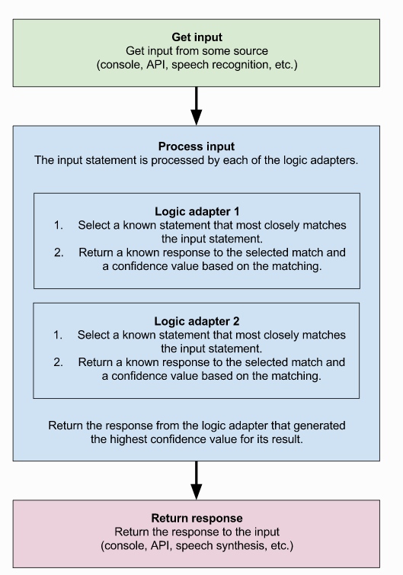

Figure 2: Process flow diagram of AI Algorithm

ChatterBot is a Python library designed to make it easy to create software that can engage in conversation.

An untrained instance of ChatterBot starts off with no knowledge of how to communicate. Each time a user enters a statement, the library saves the text that they entered and the text that the statement was in response to. As ChatterBot receives more input the number of responses that it can reply and the accuracy of each response in relation to the input statement increase.

The program selects the closest matching response by searching for the closest matching known statement that matches the input, It then chooses a response from the selection of known responses to that statement.

**College Related Response Activity:**



In this chapter i.e. Design every part of the proposed system is taken and use case diagrams, data flow diagrams and activity diagrams are made to make it easier for the reader to understand the work flow of the project.

Figure 3: College-Related Response Activity

# 5. Implementation

1. **AIML:**

AIML stands for **Artificial Intelligence Markup Language**. AIML was developed by the Alicebot free software community and Dr. Richard S. Wallace during 1995-2000. AIML is used to create or customize Alicebot which is a chat-box application based on A.L.I.C.E. (Artificial Linguistic Internet Computer Entity) free software.

The question and answer pairs are stored in the AIML files so that the base for the normal conversations can be created. The patterns in AIML are matched with the input from the user and the appropriate answer is given.

**B. Lemmatization and POS Tagging Using WordNet:**

Lemmatization is the process of converting a word to its base form. The difference between stemming and lemmatization is, lemmatization considers the context and converts the word to its meaningful base form, whereas stemming just removes the last few characters, often leading to incorrect meanings and spelling errors.

For example, lemmatization would correctly identify the base form of ‘caring’ to ‘care’, whereas, stemming would cutoff the ‘ing’ part and convert it to car.

‘Caring’ -> Lemmatization -> ‘Care’  
‘Caring’ -> Stemming -> ‘Car’

Also, sometimes, the same word can have multiple different ‘lemma’s. So, based on the context it’s used, you should identify the ‘part-of-speech’ (POS) tag for the word in that specific context and extract the appropriate lemma.

Keywords were extracted from the input text which is known as information extraction. E.g. "What is the distance from Nashik?" contains "distance", "Nashik" as the keywords. Lemmatization and POS tagging were used to find appropriate Lemmas so that proper grouping can be done. Also, WordNet from Python 3's NLTK package was used for mapping the words to their base. E.g. walking, walk, and walked should map to walk.

**C. Semantic Sentence Similarity**

There are various cases in which the user might write the same sentence differently. E.g.,

Q1: Who is the HOD of the MCA department?

Q2: Tell me about the HOD of the MCA department.

Here both the questions have the same meaning. There can be many other combinations for the same query. The problem here is that all those combinations cannot be added to the file. Hence, the performance of the system will get affected. To solve this problem, the similarity is found between the input of the user and the data present in the question set. The input with the maximum score gets selected and then the proper answer is provided.

The above-mentioned score is calculated by averaging the similarity of the individual keywords of those sentences. The word with maximum similarity is matched between the keywords of the sentences. Then the similarity score is averaged to make the sentence similarity.

Another approach is the implementation of word similarity using the Path Similarity and Wu-Palmer (WUP) Similarity is used.

Like WordNet, a hierarchical structure is assumed where the path similarity compiles the shortest number of edges from one-word sense to another. It is to be noted that the longer word sense is less similar than those with a smaller path distance. E.g. car, bus, and cycle(we expect that a bus is similar to a car and not a cycle). The Wu-Palmer metric calculates the distance using the weights in the edges.

**D. Log File:**

A log file is also maintained which store those queries which the chatbot was not able to answer. It is the work of the admin to view the log file and the responses of the sentences. All this is done into the knowledge base. This is a very important method to improve the overall functioning of the chatbot

**6. Testing**

**System Testing**

System testing involves testing of software and successful running of the developed proposed system.

System testing is the stage of implementation that is aimed at ensuring that the system works accurately and efficiently before live operation commences. Testing is vital to the success of the system. System testing makes the logical assumption that if all the parts of the system are correct, then the goal will be successfully achieved. A series of testing is done for the proposed system before the system is ready for user acceptance testing.

The following are the Testing plans:

* + - Unit Testing
    - Integration Testing
    - Validation Testing
    - Verification Testing
    - User Acceptance Testing
    1. **Unit Testing**

Unit testing focuses verification efforts on the smallest unit of the software design, the module. This is also known as module testing.

In this software, each module is tested. This testing was carried out during the programming stage. In this testing, each module is found to be working satisfactorily as regards the expected output from the module.

* + 1. **Integration Testing**

One module can have adverse efforts on another. Integration testing is the systematic testing for the construction of program structure. Thus in the integration testing step, all the errors uncovered are corrected for the next testing steps.

* + 1. **Validation Testing**

After integration testing, the software is completely assembled as a package, Invalidation testing functional or performance characteristics of an integrated package are checked.

* + 1. **Verification Testing**

Verification is a fundamental concept in software design. This is the bridge between customer requirements and an implementation that satisfies those requirements.

* + 1. **User Acceptance Testing**

The system under study is tested for user acceptance by constantly keeping in touch with the prospective system users at any time of developing and making changes whenever required.

* 1. **Test Cases**

|  |  |  |  |  |
| --- | --- | --- | --- | --- |
| **Test**  **no** | **Test**  **Description** | **Expected**  **Result** | **Obtained**  **Result** | **Status** |
| 01 | Create a connection for the user to connect with a server. | Establish a connection between servers and generate a link. | The connection is established and a link is generated. | **Pass** |
| 02 | Open a web browser and open a link | the page is open without getting a "404 Error" | The webpage is successfully opened without any error | **Pass** |
| 03 | Opening a “About college” page by clicking on “info” button | Redirecting to “About college” without getting “Page Not Found” Error | Page is successfully opened without any error window. | **Pass** |
| 04 | Ask a Query related to the MCA department | Getting a response to a query asked to Chatbot | The response is received of a query related to the MCA department | **Pass** |
| 05 | Ask a Query that is not related to college or MCA department | Getting a response to a query asked to Chatbot | The response is received of a query that is not related to the MCA department | **Pass** |
| 06 | Get a Google form link for collecting data of user. | Getting a link from Chatbot for data collection | Link is received while ending the conversation with user | **Pass** |

**7. Result and Analysis**

**Test case 1 result: Create a connection for the user to connect with a server.**

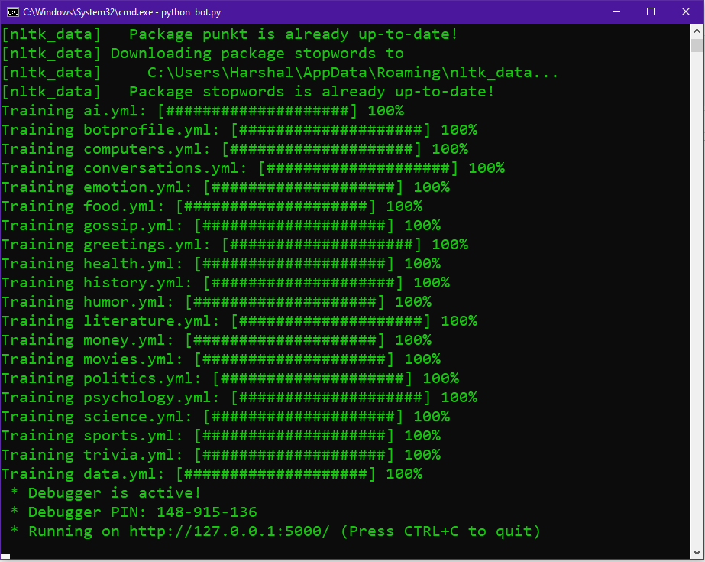

**Test case 2 results:** Open a web browser and open a link

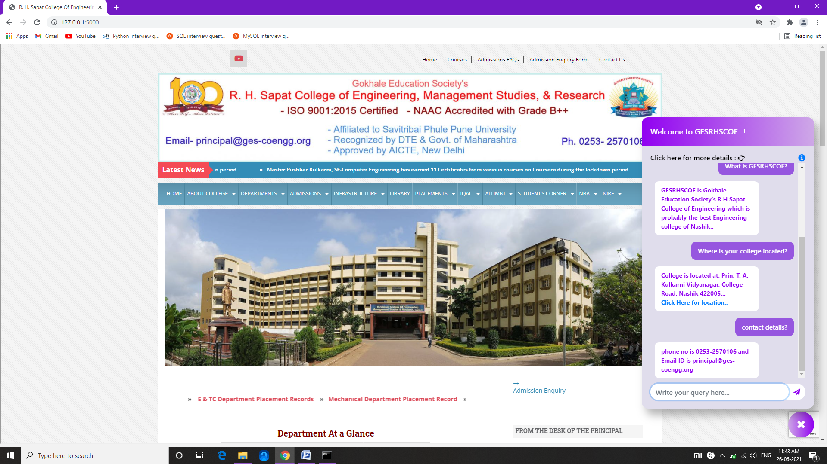

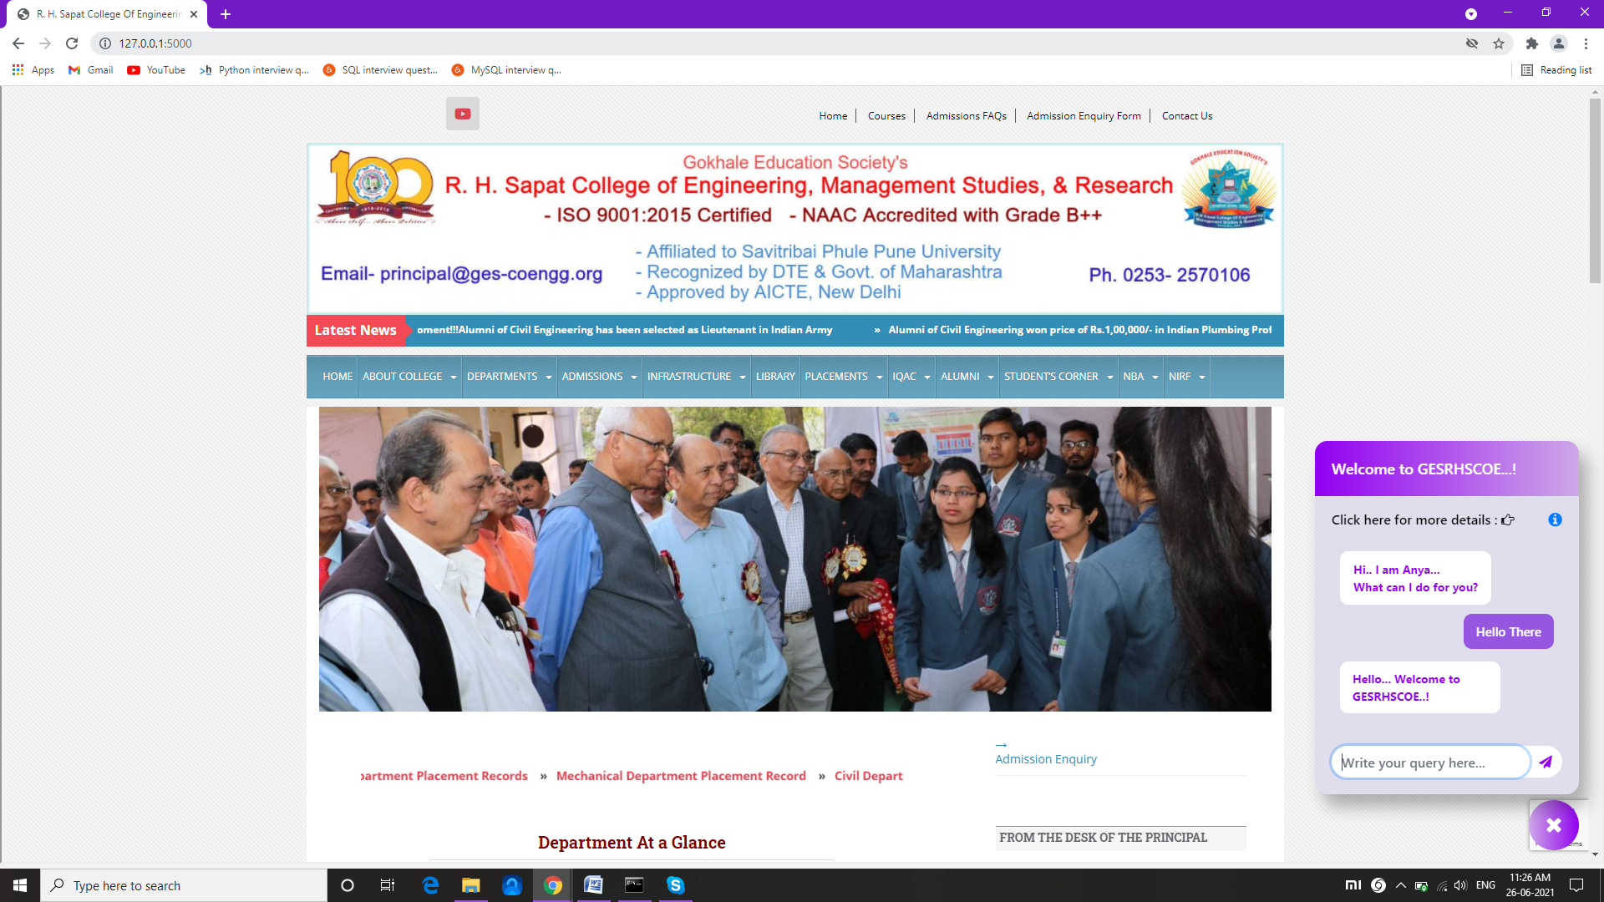

**Test case 3 results:** Opening a “About college” page by clicking on “info” button

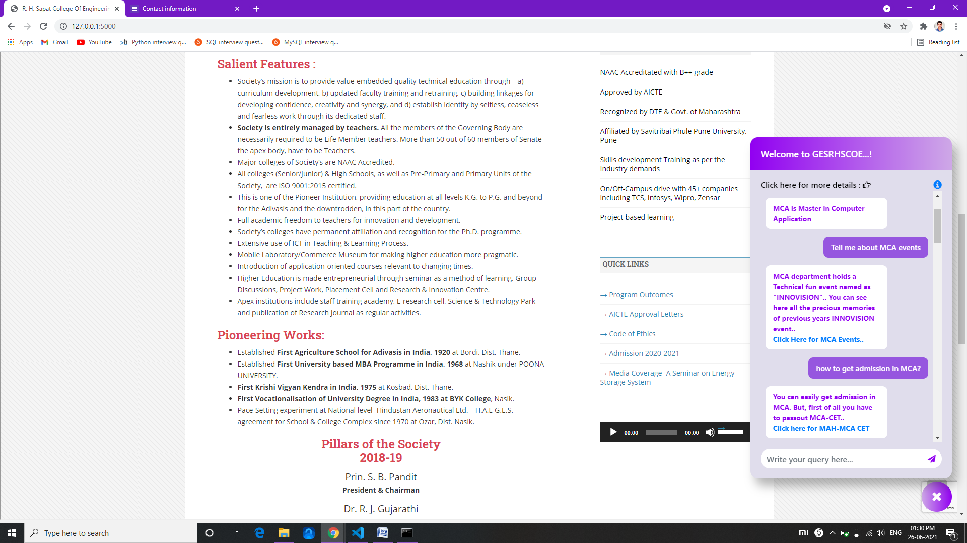

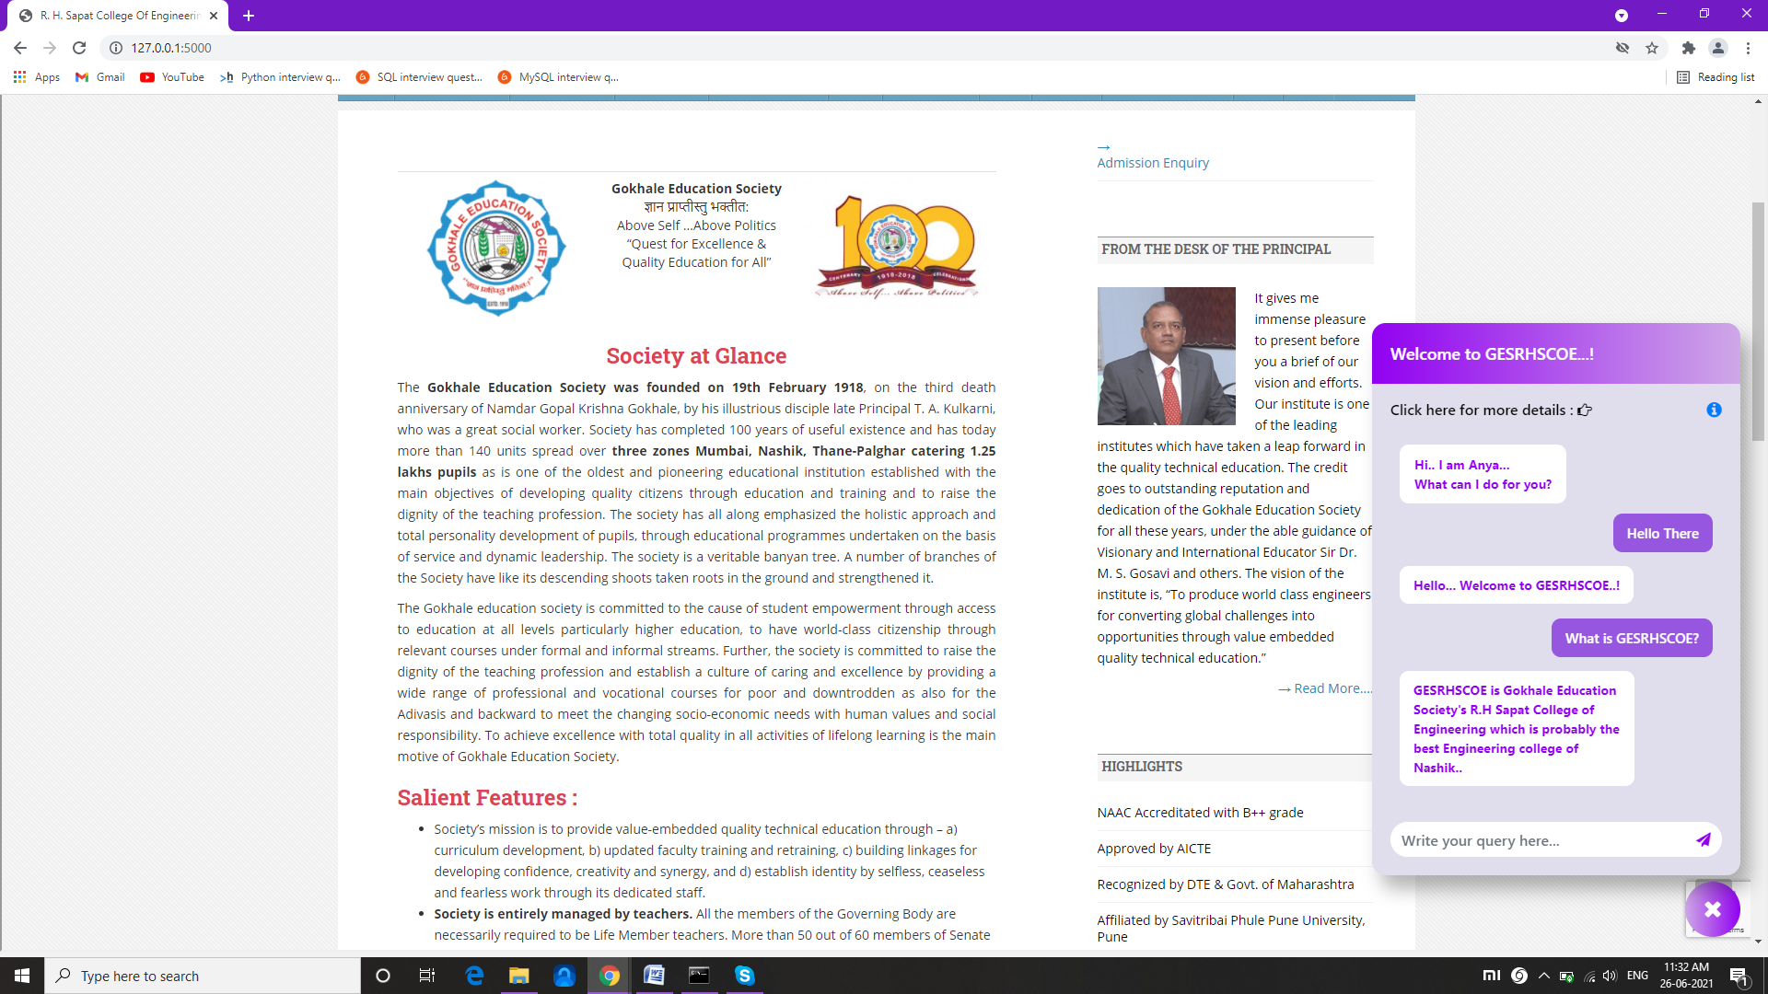

**Test case 4 results:** Ask a Query related to the MCA department

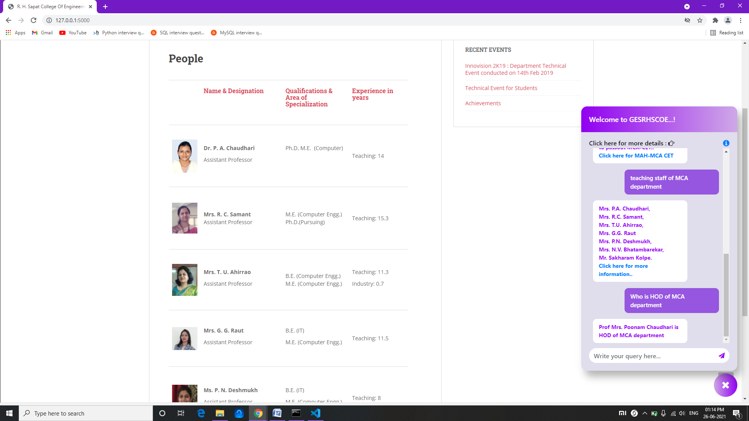

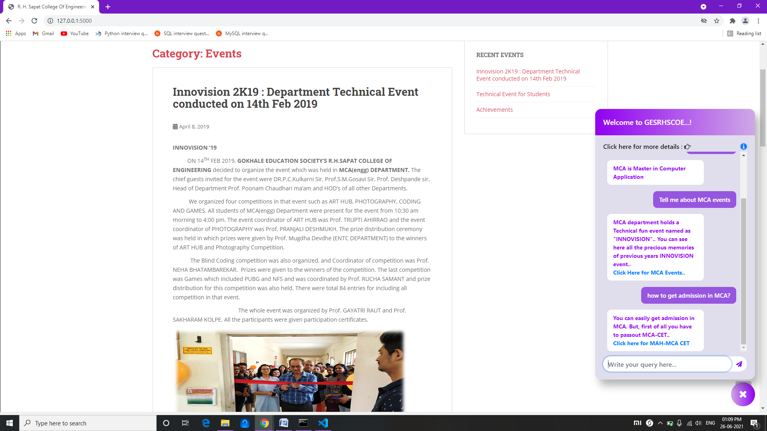

**Test case 5 results:** Ask a Query that is not related to college or MCA department

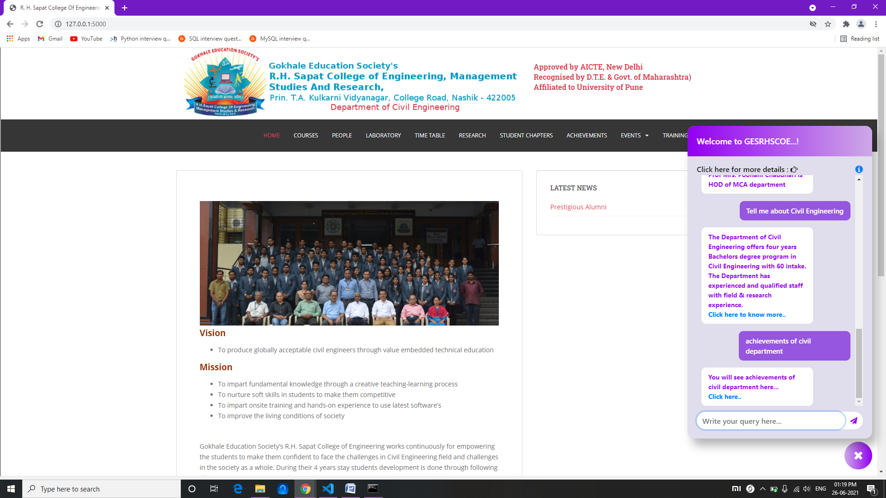

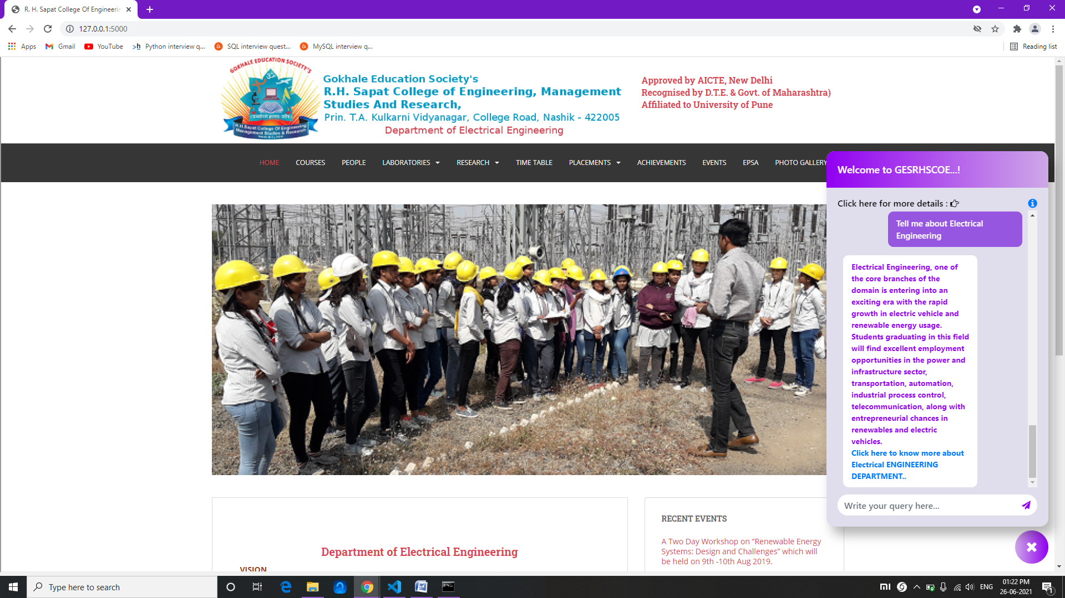

**Test case 6 result: Get a Google form link for collecting data of user.**

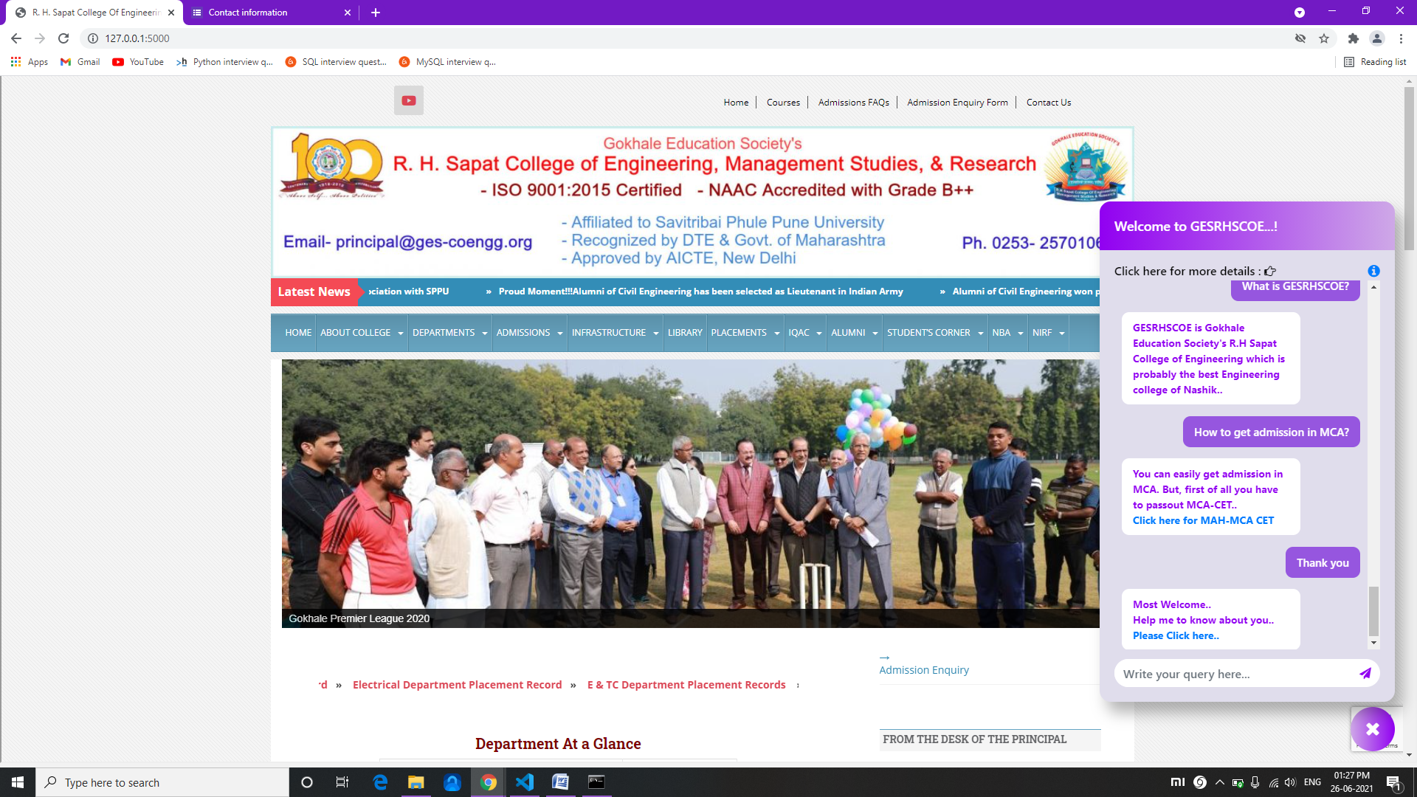

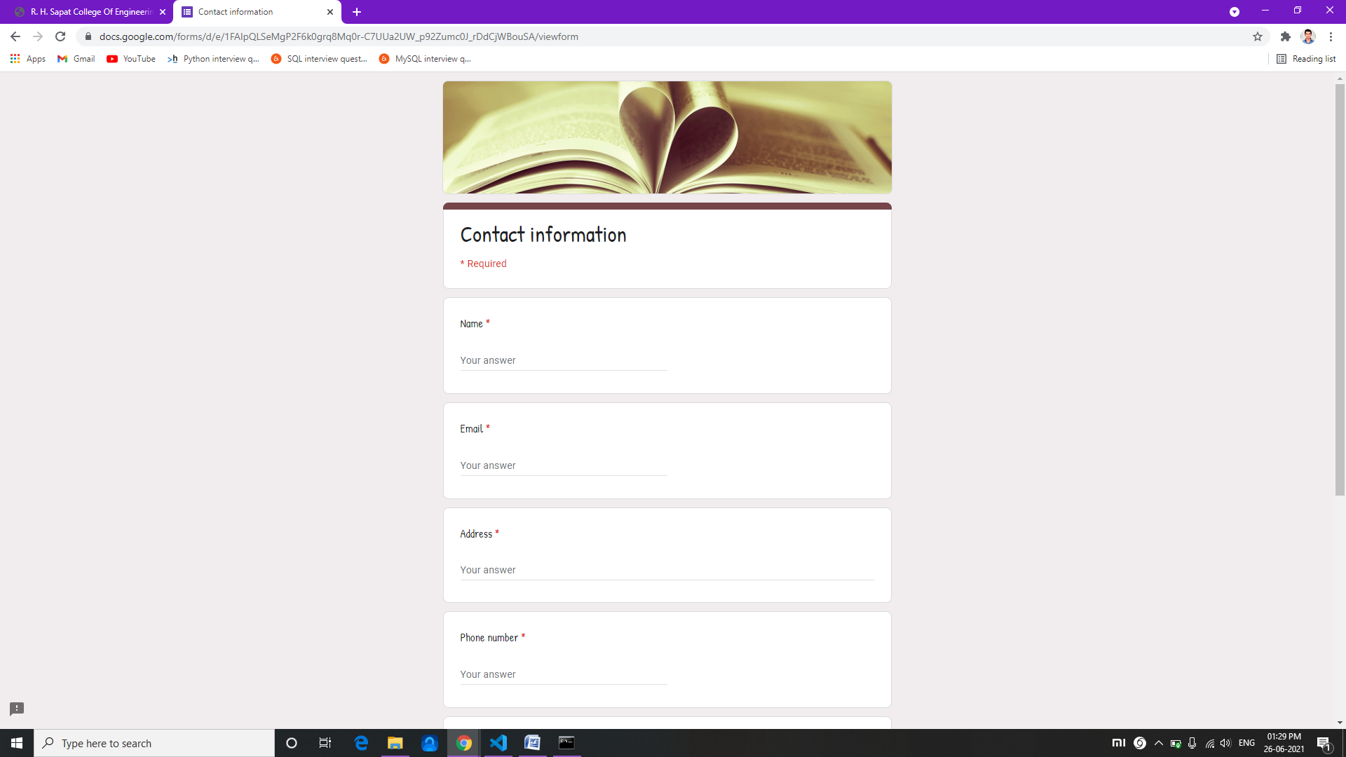

**8. Conclusion and Future scope**

* 1. **Conclusion**
* What we can conclude from the above situation and usage is that greater the database and more the models and use cases, the better are the reaction produced for the client. In any case, the issues are many. For adjusting more uses, the scope changes from the investigation of AI to language examine.
* The main objectives are to develop an algorithm that will be used to identify answers related to user-submitted questions. To develop a database where all the related data will be stored and to develop a web interface.
* The web interface developed had two parts, one for simple users and one for the administrator. Background research took place, which included an overview of the conversation procedure and any relevant chatbots available.
* We will create a database, which stores all the information about questions, answers, keywords, logs, and feedback messages.
* A usable system will be designed, develop, and deploy to the web server.

**Future scope**

The 21st century has seen the advancement in technology and its impact on the people. In many ways, the technology innovation has helped to make the lives of the people easier.

It is widely known that information is carried out from one person to another. When someone does not know about something, he asks the other person. That way the information is carried on. Keeping this fact in mind when the computers came into existence, some of the scholars and scientists came up with the idea of making them answer the problems of the people. By creating this portal, the users could get their problems answered.

Google started with a simple web application which answered the queries of the people but that was something different from one on one talk. So it introduced the concept of Google Assistant through which every user could talk. Not only the user can talk but it is equipped with top notch features today.

You might have heard the statement “Something that works perfectly doesn’t mean it can’t be upgraded”. Keeping this thought in mind, this project can also be upgraded to a much higher extent according to the need.

One of the major additions that can be done is the introduction of Voice API in the near future. The users will give the queries through their voice and the system will give text and voice output both.

**9. References**

**References**

1. [http://www.stalckoverflow.com](http://www.stalckoverflow.com/)
2. https://www.tutorialspoint.com/python/index.html
3. [http://www.coderanch.com](http://www.coderanch.com/)
4. https://youtu.be/u5hx_YtqylA
5. https://www.youtube.com/watch?v=ZzntTdwrOyc
6. https://codinginfinite.com/chatbot-in-python-flask-tutorial/
7. https://youtu.be/EW9I1HqaKwk #full video tutorial
8. https://www.youtube.com/watch?v=n7MpWHi8T7Q